Topic A: The Blessings of the Lord's Church - Lección 11
Question: Why is it so important to go to Church?

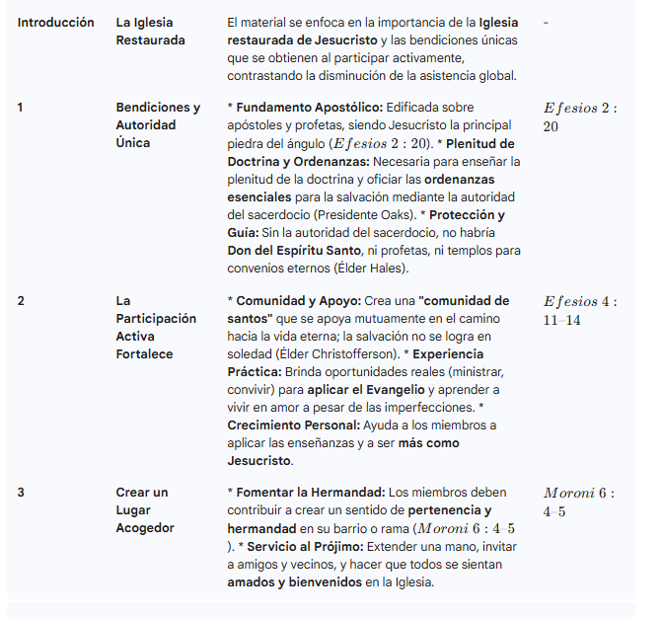

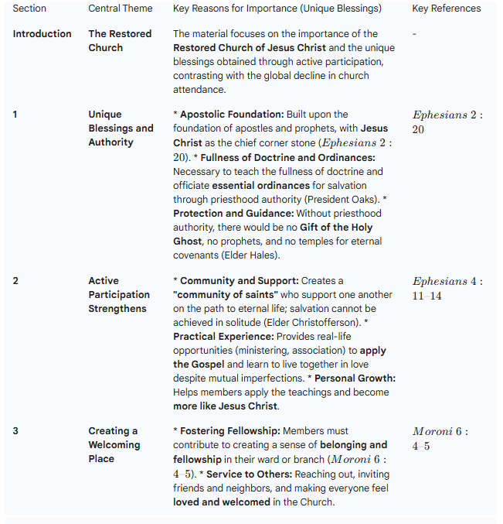
Topic B: The Teachings of Jesus Christ - Lección 12
Question: What can I do if I feel the Gospel isn't working for me?

Summary: Finding Pure Truth in the Teachings of Jesus Christ
The text addresses the need to seek pure truth in the teachings of Jesus Christ in the digital age, where the information overload means few people know where to look for it (President Russell M. Nelson). Christ's teachings are the supreme source of pure truth with the power to guide, strengthen, and transform one's life.

Section 1: How the Teachings of Jesus Christ Improve My Life
Power and Authority: Jesus taught with the "authority of God," and His word was with power ($Luke\ 4:32$).
Impact on Disciples: The Savior's teachings, based on the scriptures, caused the hearts of the disciples on the road to Emmaus to burn within them ($Luke\ 24:32$).
The Challenge of Doctrine: Christ's teachings can be challenging, leading some people to turn away. To remain faithful, simply hearing His words is not enough.
The Importance of Action (Practice): The key to benefit and testimony is to act upon His teachings:
"He that doeth truth cometh to the light" ($John\ 3:21$).
"If any man will do his will, he shall know of the doctrine, whether it be of God" ($John\ 7:17$).
"Happy are ye if ye do them" ($John\ 13:17$).
"What then?": The Savior expected His sermons to change the lives of His disciples, as the connection between what one believes and how one lives is essential (Elder Jeffrey R. Holland).

Section 2: The Most Essential Teachings for Salvation
Truths of Greater Worth: While all truth is worth knowing, some truths are of more worth to know (President Boyd K. Packer).
The Gospel of Jesus Christ: The Savior Himself taught that His gospel is fundamental to salvation, and His gospel is:
His Atoning Sacrifice (Elder Daniel K. Judd).
The invitation to receive the blessings of the Atonement through: Faith in Christ, repentance, baptism, receiving the Holy Ghost, and enduring faithfully to the end ($3\ Nephi\ 27:13–14, 19–21$).
Focus on Fundamentals: It is vital to focus on the fundamental doctrines instead of spending valuable time on less important topics and sources. If the Gospel isn't working well, it is advised to simplify the approach and focus on the basic principles (President Dieter F. Uchtdorf)



